

# American International University-Bangladesh (AIUB)

Department of Computer Science Faculty of Science &Technology (FST)

Spring 22-23

Section: C

Software Quality Assurance and Testing

Vehichle Parts ecommerce Site

## A Report submitted By

|  |  |  |
| --- | --- | --- |
| SN | Student Name | Student ID |
| 1 | Annafi Bin Alam | 19-40258-1 |
| 2 | Sarmin Akter Lipsy | 19-40700-1 |
| 3 | MD.Abdul Mukit | 19-40921-2 |
| 4 | Sabbir Ahamed Sezan | 19-41034-2 |

Software Test Plan

for

Vehicle Parts

## Version 1.0 approved

Prepared by

Annafi Bin Alam

Sarmin Akter Lipsy

MD. Abdul Mukit

Sabbir Ahamed Sezan

**American International University-Bangladesh (AIUB)**

## 27 April,2023

**Checked By Industry Personnel**

Name:

Designation:

Company:

Sign:

Date:

Table of Contents

Revision History 3

1. TEST PLAN IDENTIFIER: RS-MTP01.3 4

2. REFERENCES 4

3. INTRODUCTION 4

Background to the Problem 4

Solution to the Problem 4

4. REQUEIREMNT SPECIFICATION 4

4.1 System Features 5

4.2 System Quality Attributes 7

4.3 System Interface 8

4.4 Project Requirements 12

5. FEATURES NOT TO BE TESTED 12

6. TESTING APPROACH 13

6.1 Testing Levels 13

6.2 Test Tools 14

6.3 Meetings 16

7. TEST CASES/TEST ITEMS 17

8. ITEM PASS/FAIL CRITERIA 25

9. TEST DELIVERABLES 25

10. STAFFING AND TRAINING NEEDS 25

11. RESPONSIBILITIES 25

12. TESTING SCHEDULE 26

13. PLANNING RISKS AND CONTINGENCIES 27

14. APROVALS 27

# Revision History

|  |  |  |  |
| --- | --- | --- | --- |
| Revision | Date | Updated by | Update Comments |
| 0.1 | /08/2022 | Annafi Bin Alam | First Draft |
| 0.2 | 10/08/2022 | Sarmin Akter Lipsy | Second Draft |
| 0.3 | 11/08/2022 | Whole team member | Third Draft |
| 0.4 | 12/08/2022 | Whole team member | Fourth Draft |
|  |  |  |  |
|  |  |  |  |
|  |  |  |  |
|  |  |  |  |
|  |  |  |  |

## TEST PLAN IDENTIFIER: SPM-TP2.1

## REFERENCES

* + <https://github.com/Rafin786/webtech>
  + <https://www.softwaretestingmaterial.com/test-plan-template/>

## INTRODUCTION Background to the Problem

* + The majority of us own Vehicles, and these vehicles frequently need maintenance and repairs. The problem with repairs is that it can be very difficult to locate a single location where we can get appropriate parts for our vehicle and be confident in their quality. Vehicle maintenance would be less difficult if there was a consistent and simple answer to this issue.
  + The lack of reliable information on where to find the part we need in the market is the primary cause of this issue. This issue is crucial because people are owning and operating more vehicles than ever before, which necessitates the need for more parts for repairs.

## Solution to the Problem

* + Having a single, centralized location with all the spare parts and information for practically all the vehicles is the answer to this issue.
  + The software created to address this issue serves as a single page for finding replacement parts. Because of this software, we can avoid visiting various locations in search of the parts we need. Our intention is to reduce the inconvenience and informational gap that customers experience.
  + Our study indicates that there are locations to purchase parts, but they are also troubled by the same problems. There isn't a single location where we can find all the components we might need and the necessary data.

## REQUEIREMNT SPECIFICATION

## System Features

* + 1. Customer Login Functional Requirement
* Customer can Login to the system.
* A notification will appear if the login or password are entered incorrectly.
* The username and password fields cannot be blank.
* The page will reload and let you try again if the password is incorrect.

Priority Level: High

Precondition: user have valid user id and password

* + 1. Admin Login Functional Requirement
* Admin can Login to the system.
* The username and password fields cannot be blank.
* If the password is wrong, the website will reload and you can try again.
* If the password is wrong the page will reload and let you try again.

Priority Level: High

Precondition: user have valid user id and password

* + 1. Seller Login Functional Requirement
* Seller can Login to the system.
* If the username and/or password has been inserted wrong, an error message will show.
* The username and password fields cannot be blank.
* If the password is wrong the page will reload and let you try again.

Priority Level: High

Precondition: user have valid user id and password

* + 1. System Registration (Seller and User) Functional Requirement
* Users can choose to register for a seller or user account.
* The fields cannot be blank.
* There are checks for strong passwords and correct email and phone numbers.
* There are checks for proper and unique usernames.

Priority Level: High Precondition: None.

* + 1. Cart operation Functional Requirement
       - Users can add different items to the cart before checking out.
       - There can be multiple parts from different sellers in the cart.
       - The cart must have some products before checking out
       - Users can remove previously selected items from the cart.
       - Users can see the addition and removal of items inside the cart in real time.

Priority Level: High

Precondition: Users must be logged in using valid username and password.

* + 1. Payment system Functional Requirement
       - The user will select payment options.
       - After successful payment the user will get a confirmation on their phone.
       - Users must input valid payment and contact information before checking out.

Priority Level: High

Precondition: Users must be logged in using valid username and password.

* + 1. Admin Dashboard Functional Requirement
* Admins will be able to add and remove accounts.
* Buyers and sellers are verified by the admin.
* Admins are allowed to block accounts.
* Admins are allowed to edit, delete, view product information.

Priority Level: High

Precondition: Admins must be logged in using valid username and password.

* + 1. Seller Dashboard Functional Requirement
* Sellers can add products.
* Sellers can modify previously added product details or delete them.
* Sellers are allowed to contact the admin account.
* Sellers can view the products that they have created.

Priority Level: High

Precondition: Sellers must be logged in using valid username and password.

* + 1. Customer Dashboard Functional Requirement
* Customers can see the product after selecting a specific vehicle brand, model.
* Customers can add the product they require to the cart.

Priority Level: High

Precondition: Customer must be logged in using valid username and password.

## System Quality Attributes

System quality attributes in software solutions improve the ROI (return on investment) from IT systems and also produce a better-quality application.

* **Usability:** how well a system is being used by the user and how simple it is for people to learn how to use or control the system under various OS systems. The widely recognized usability tenet is KISS (Keep It Simple, Stupid). Applications for software should be user-friendly.
* **Maintainability:** Our software solution is simple to maintain and supports changes affordably.
* **Performance:** The system will take less time like 5 to 10 sec to show the result to the user. By trained User, user operations will do in less time.
* **Security:** The system will resist or block malicious or unauthorized attempts that destroy the system and at the same time provide access to legitimate users.

## System Interface

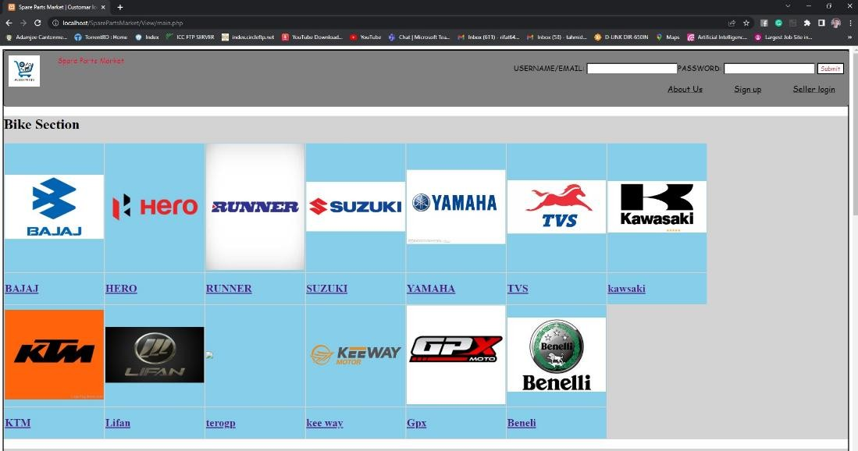o Draw the system interface where the users will interact with the system’s functionality.

*Figure 1: Customer Login page*

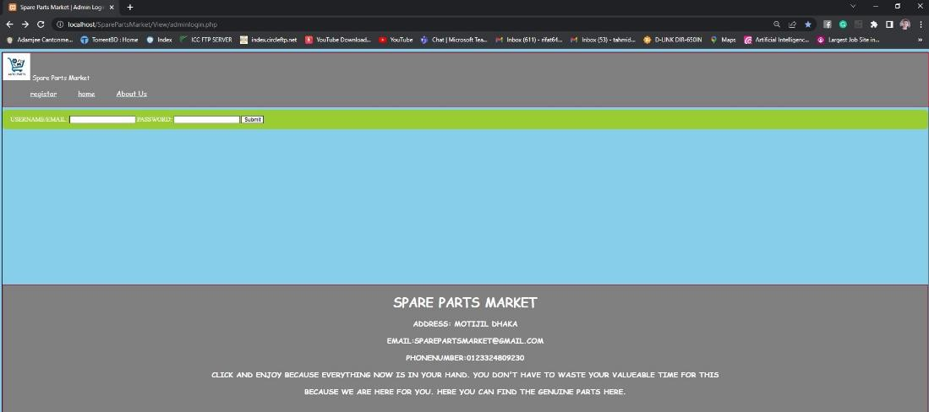

*Figure 2: Admin Login*

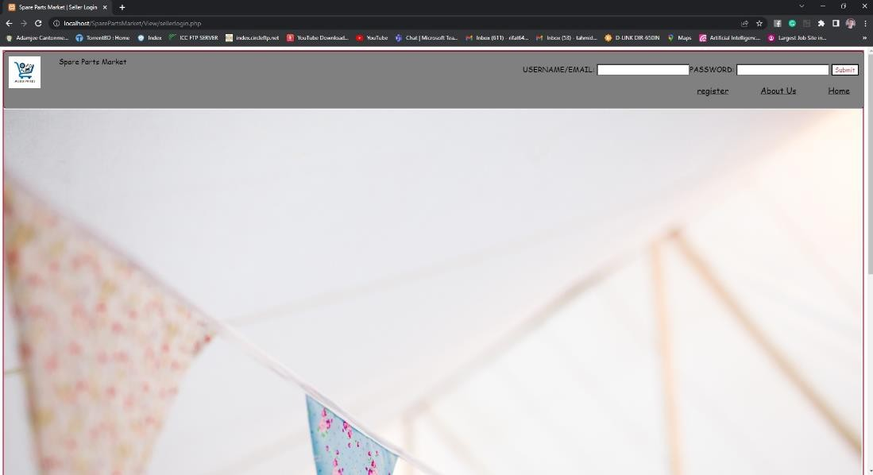

*Figure 3: Seller/Vendor Login*

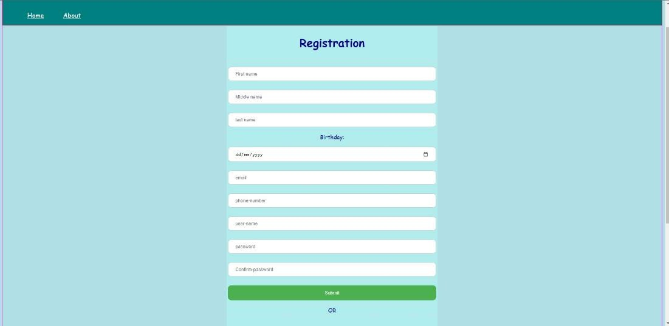

*Figure 4: Registration*

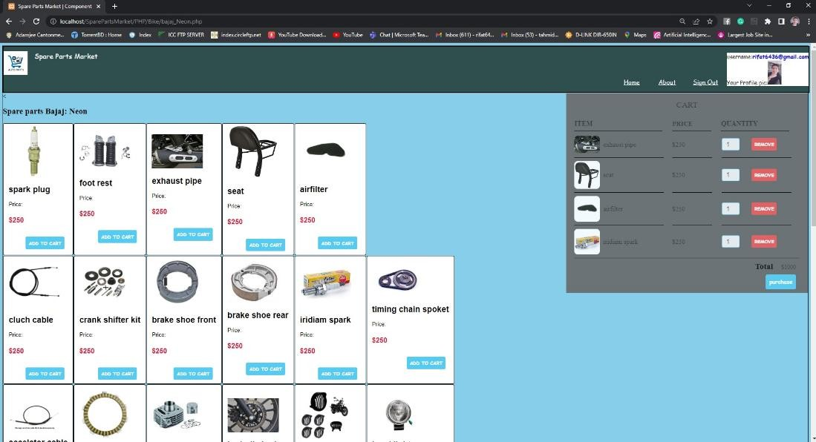

*Figure 5: Cart Operation*

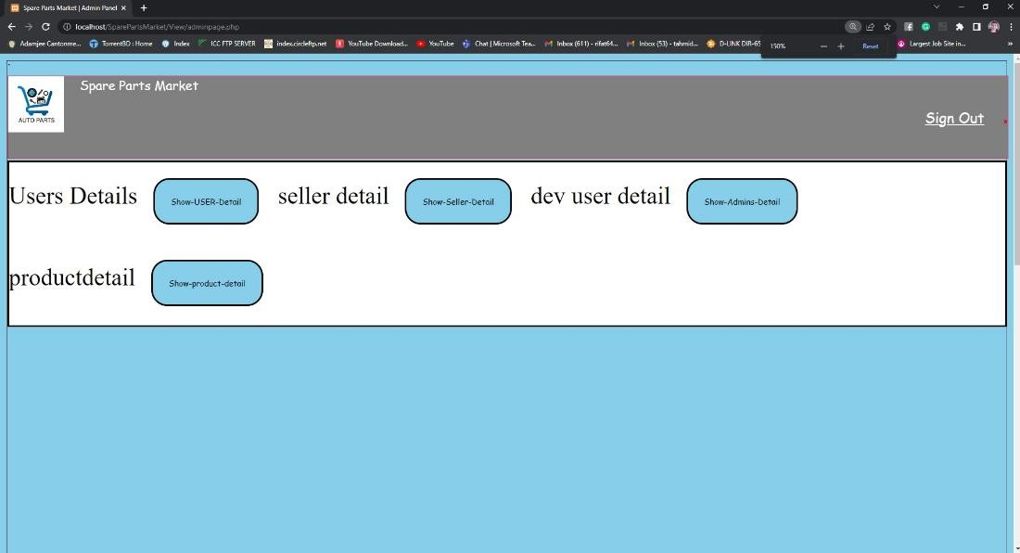

*Figure 6: Admin Dashboard*

## Project Requirements

**Time constraint:**  It took no more than 10 months to 1 year to develop.

**Scope constraint:**  At the start of the project, provide clear documentation of the whole project scope, including all needs. Create a procedure for managing changes so that, in the event that someone makes a change proposal, there is a controlled process in place for how the change will be examined, approved or rejected, and, if necessary, implemented. Give stakeholders frequent and clear updates on the scope.

**Cost constraint:** it will cost approx. 200000 BDT. For labor and cost of goods.

## FEATURES NOT TO BE TESTED

The areas that won't be specifically discussed are listed below. As a result of other testing initiatives, all testing in these areas will be indirect. For example:

1. Since this is an internet store, we won't test the location feature since it is an open-source Google map project.
2. We are counting on customers to use hardware (Cell phones) at least newer then 6 years as any older devices might have serious security flaws
3. The product browser page will have the least security.
4. We will assume our customers will have a stable internet connection.
5. We assume the customer will give all the proper information’s.
6. We assume the customer will be technically literate enough to understand the UI.

## TESTING APPROACH

## Testing Levels

All requirements for an appropriate test will be followed during the market for spare parts project testing. We'll make sure the program passes each of the acceptance tests before doing an accurate evaluation of the system. A different test team will perform system integration testing.

As long as the time and financial constraints are known, we can create software that is better.

* + - **UNIT Testing** will be done by the developer and will be approved by the development team leader. Proof of unit testing (test case list, sample output, data printouts, and defect information) must be provided by the programmer to the team leader before unit testing will be accepted and passed on to the test person. All unit test information will also be provided to the test person.
    - **SYSTEM/INTEGRATION** The development team leader and test manager will oversee testing, with any necessary assistance from the individual developers. For this project, there are no specialized test tools available. After all critical flaws have been fixed, programs move on to the System/Integration test. As long as the errors can be fixed, a program may contain up to two major flaws that do not prevent testing of the software. Black box testing, scalability test, reliability test, robustness test, document test, regulatory test, security testing, safety testing, performance testing.
    - **ACCEPTANCE** The development team leader and test manager will provide help to the actual end users as they do testing. One month after the System/Integration test process is finished, the acceptance test will be conducted concurrently with the current manual ZIP/FAX procedure.
    - User acceptance testing (UAT), Business acceptance testing (BAT).

## Test Tools

We used Jira, selenium to test the software efficiently

* + - We used Jira to keep track of all tasks using serum board.
    - The initial prototype was tested using selenium.
    - Microsoft visual studio IDE was used if selenium was unable to fix the module
    - Intelij Idea IDE is used for java coding for Selenium.

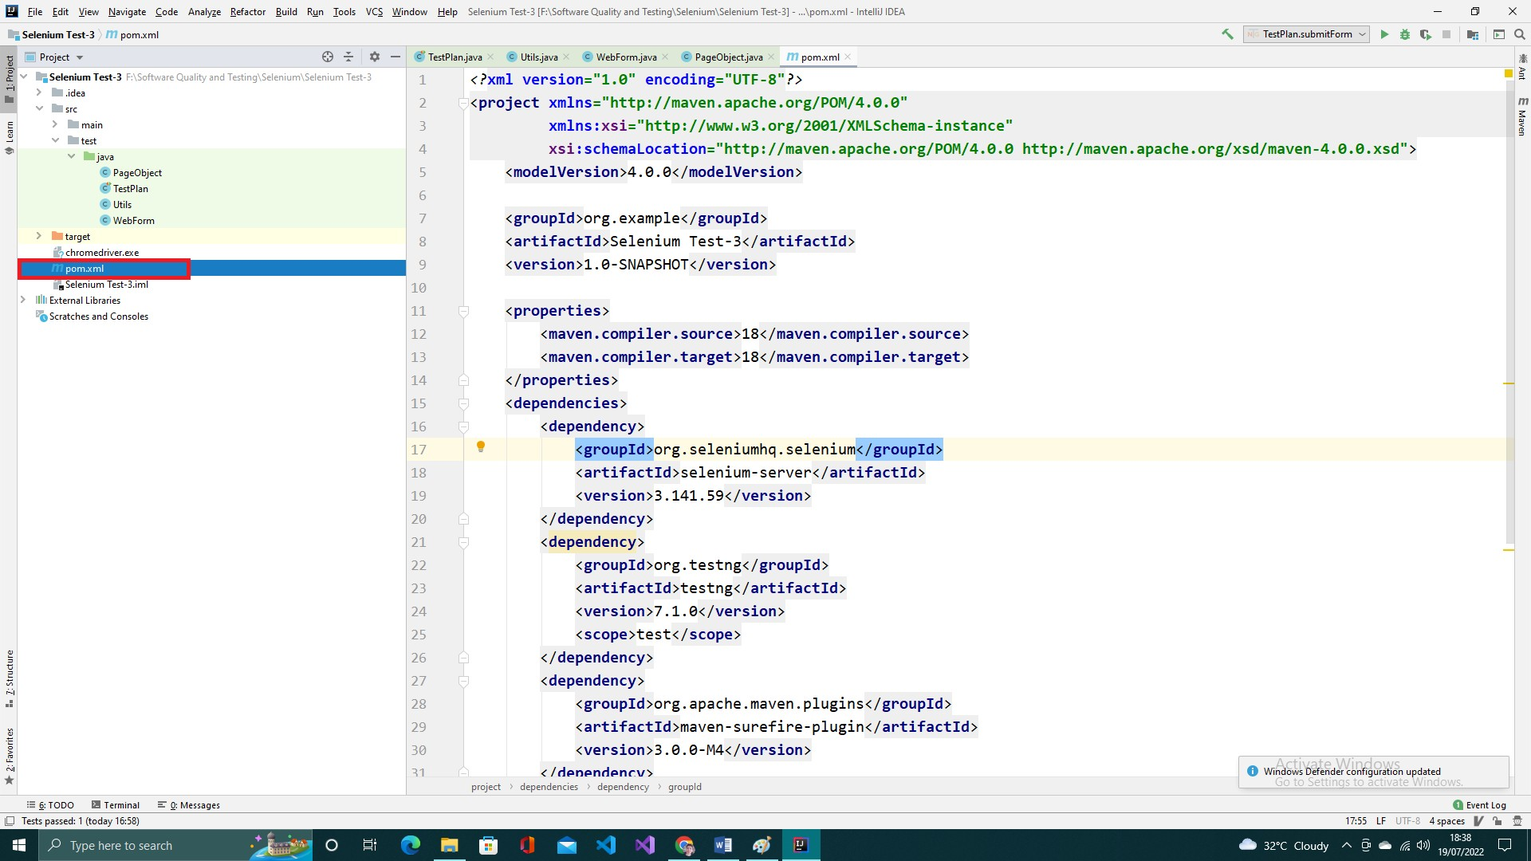

*Figure 7: java (Selenium) code for testing*

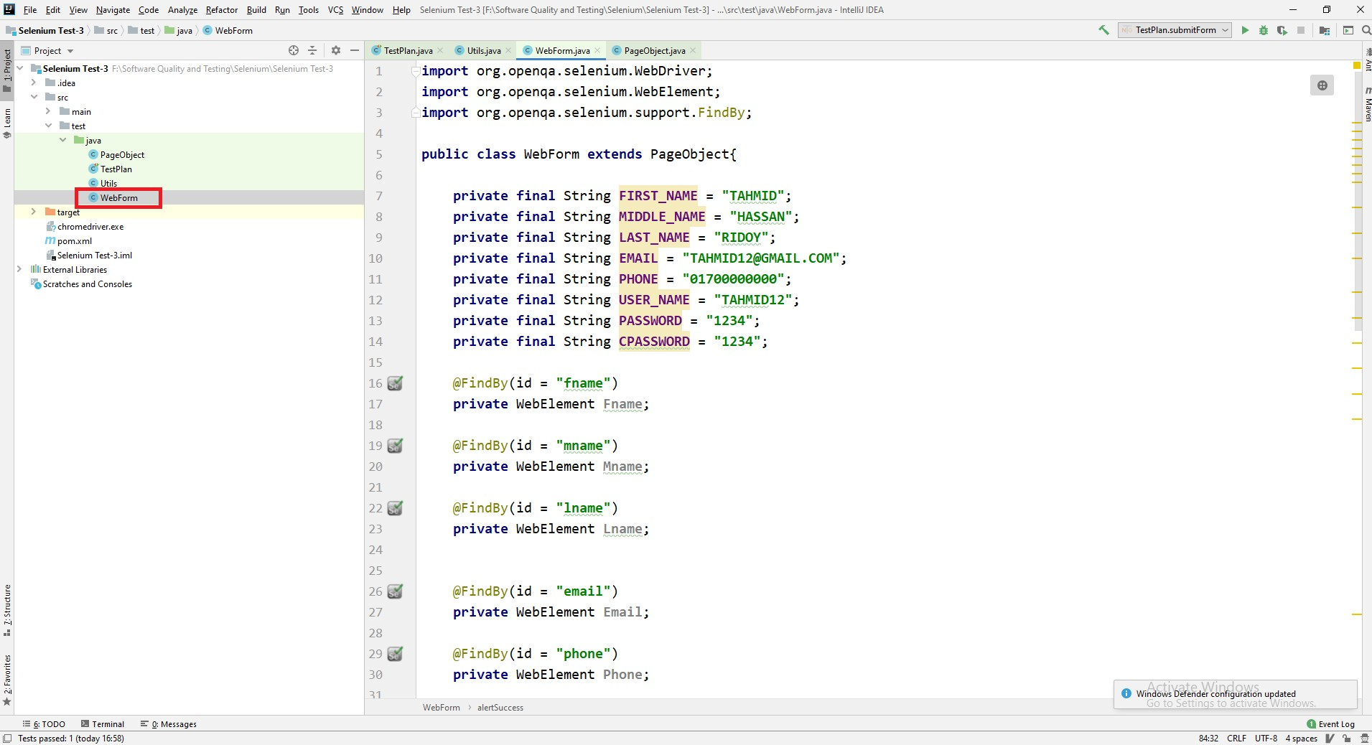

*Figure 8: java (Selenium) code for testing*

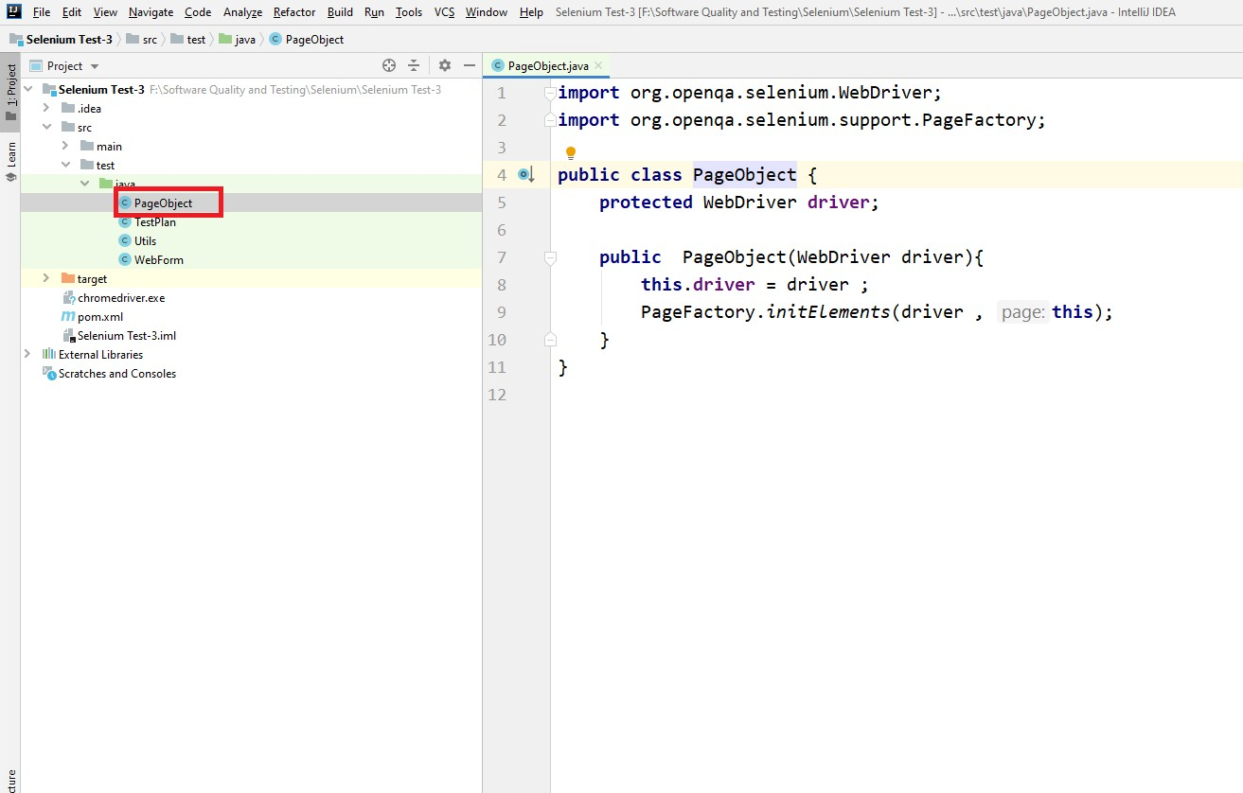

*Figure 9: java (Selenium) code for testing*

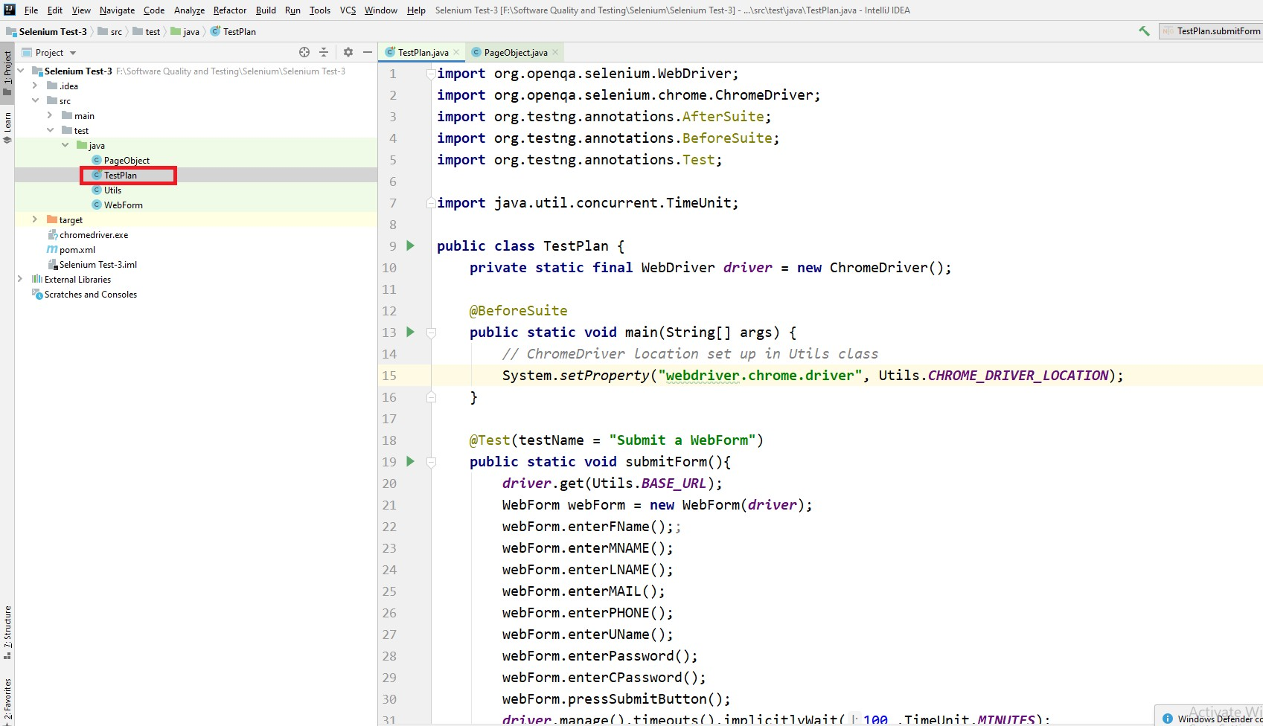

*Figure 10 : java (Selenium) code for testing*

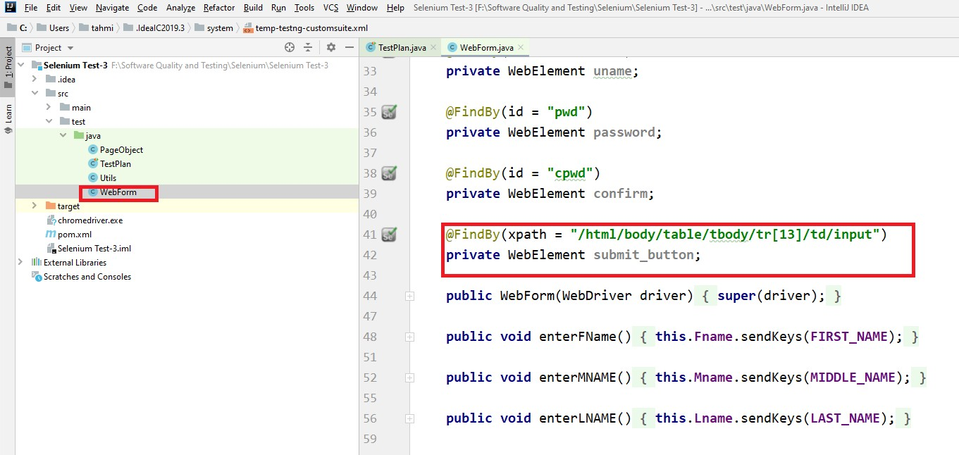

*Figure 11 : java (Selenium) code for testing*

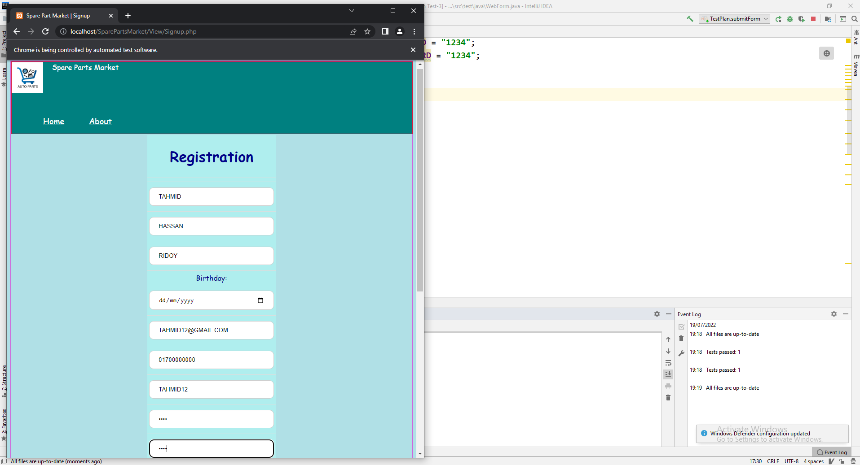

*Figure 12 : While Testing using selenium*

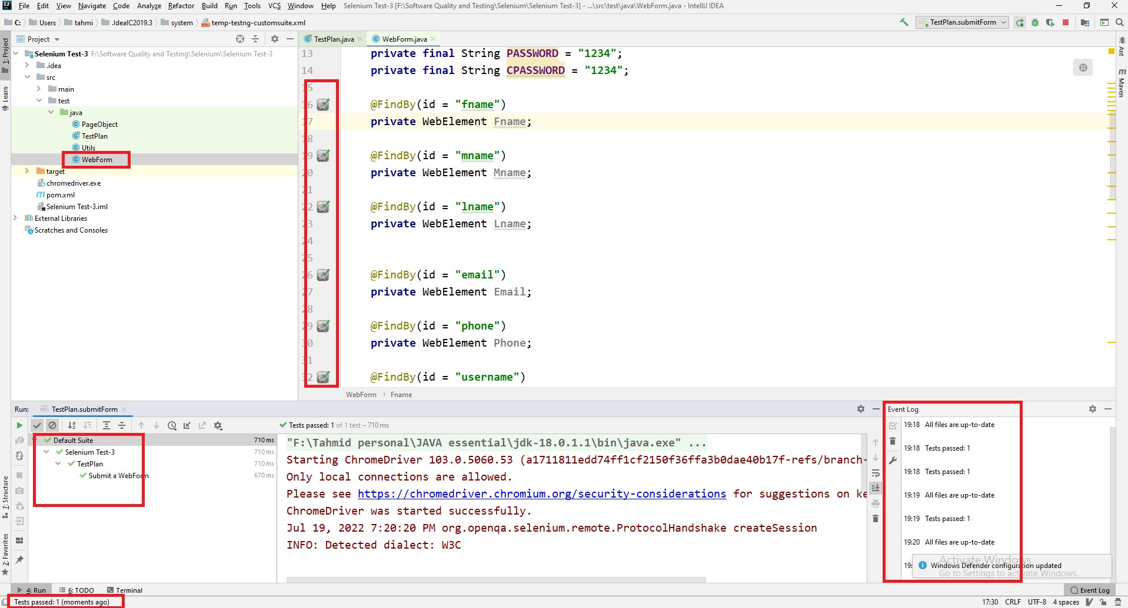

*Figure 13 : Test Result*

## Meetings

o The project is deemed successful when all of the modules and tests have been successfully completed. It takes weekly team meetings to get this result. Each team member must use the scrum board to ensure proper responsibility and productive growth. Each team as well as the development, testing, and management teams.The meeting should begin with all team members present.

## TEST CASES/TEST ITEMS

|  |  |  |  |  |  |
| --- | --- | --- | --- | --- | --- |
| Project Name: Spare Vehichle Parts | | | Test Designed by: Annafi | | |
| Test Case ID: SPM_1 | | | Test Designed date: 13/04/2023 | | |
| Test Priority (Low, Medium, High): High | | | Test Executed by: Annafi | | |
| Module Name: Customer Login | | | Test Execution date: 14/04/2023 | | |
| Test Title: verify login with valid username and password | | |  | | |
| Description: Test customer login page | | |  | | |
| Precondition (If any): User must have valid username and password | | | | | |
| Test Steps | Test Data | Expected Results | | Actual Results | Status (Pass/Fail) |
| 1. Go to the website 2. Enter username 3. Enter password 4. Click submit | Username: User1  Password: 123 | Customer should login into the application | | As expected, | Pass |
| Post Condition: User is validated with database and successfully login to account. The account session details are logged in the database. | | | | | |

|  |  |  |  |  |  |
| --- | --- | --- | --- | --- | --- |
| Project Name: Spare Vehichle Parts | | | Test Designed by: Annafi | | |
| Test Case ID: SPM_2 | | | Test Designed date: 13/04/2023 | | |
| Test Priority (Low, Medium, High): High | | | Test Executed by: Annafi | | |
| Module Name: Admin Login | | | Test Execution date: 14/04/2023 | | |
| Test Title: verify login with valid username and password | | |  | | |
| Description: Test admin login page | | |  | | |
| Precondition (If any): User must have valid username and password | | | | | |
| Test Steps | Test Data | Expected Results | | Actual Results | Status (Pass/Fail) |
| 1. Go to the website 2. Enter username 3. Enter password 4. Click submit | Username: Admin  Password: 123 | Admin should login into the application | | As expected, | Pass |
| Post Condition: User is validated with database and successfully login to account. The account session details are logged in the database. | | | | | |

|  |  |  |  |  |  |
| --- | --- | --- | --- | --- | --- |
| Project Name: Spare Vehichle Parts | | | Test Designed by: Lipsy | | |
| Test Case ID: SPM_3 | | | Test Designed date:13/04/2023 | | |
| Test Priority (Low, Medium, High): High | | | Test Executed by: Lipsy | | |
| Module Name: seller Login | | | Test Execution date: 14/04/2023 | | |
| Test Title: verify login with valid username and password | | |  | | |
| Description: Test seller login page | | |  | | |
| Precondition (If any): User must have valid username and password | | | | | |
| Test Steps | Test Data | Expected Results | | Actual Results | Status (Pass/Fail) |
| 1. Go to the website 2. Enter username 3. Enter password 4. Click submit | Username: seller  Password: 456 | Seller should login into the application | | As expected, | Pass |
| Post Condition: User is validated with database and successfully login to account. The account session details are logged in the database. | | | | | |

|  |  |  |  |  |  |
| --- | --- | --- | --- | --- | --- |
| Project Name: Spare Vehichle Parts | | | Test Designed by: Lipsy | | |
| Test Case ID: SPM_4 | | | Test Designed date:13/04/2023 | | |
| Test Priority (Low, Medium, High): High | | | Test Executed by: Lipsy | | |
| Module Name: System registration | | | Test Execution date: 14/04/2023 | | |
| Test Title: verify login with the required information | | |  | | |
| Description: Test registration page | | |  | | |
| Precondition (If any): User must have valid username and password | | | | | |
| Test Steps | Test Data | Expected Results | | Actual Results | Status (Pass/Fail) |
| 1. Go to the website 2. Enter name 3. Birthday 4. Email 5. Phone number 6. username 7. Enter password 8. Confirm password 9. Click submit | First name: Jhonny  Middle name: Billy  Last name: Bravo  Birthday: 20/4/2000  Email: [xyz@gmail.com](mailto:xyz@gmail.com)  Username: test user  Password: 321 | User should register successfully and redirect to the login page | | As expected, | Pass |
| Post Condition: User data stored in database and show successfully registered account. | | | | | |

|  |  |  |  |  |  |
| --- | --- | --- | --- | --- | --- |
| Project Name: Spare Vehichle Parts | | | Test Designed by: Mukit | | |
| Test Case ID: SPM_5 | | | Test Designed date:13/04/2023 | | |
| Test Priority (Low, Medium, High): High | | | Test Executed by: Mukit | | |
| Module Name: Cart operation | | | Test Execution date: 14/04/2023 | | |
| Test Title: verify the cart operations | | |  | | |
| Description: Test the functionality of the cart | | |  | | |
| Precondition (If any): must be logged in with valid username and password. Product must be stored in database. | | | | | |
| Test Steps | Test Data | Expected Results | | Actual Results | Status (Pass/Fail) |
| 1. Go to the website 2. Select a brand, mode. 3. Select part and add to cart 4. Add more parts to cart 5. Remove items from cart | Input quantity | User should be able to add, remove and update the items in cart | | As expected, | Pass |
| Post Condition: User order id and ordered Item with date and payment information should be stored n database. User can see the confirmed order from Database. | | | | | |

|  |  |  |  |  |  |
| --- | --- | --- | --- | --- | --- |
| Project Name: Spare Vehichle Parts | | | Test Designed by: Mukit | | |
| Test Case ID: SPM_6 | | | Test Designed date: 13/04/2023 | | |
| Test Priority (Low, Medium, High): High | | | Test Executed by: Mukit | | |
| Module Name: Payment System | | | Test Execution date: 14/04/2023 | | |
| Test Title: Verify that the all the payment methods work | | |  | | |
| Description: Test website payment page | | |  | | |
| Precondition (If any): must be logged in with valid username and password. | | | | | |
| Test Steps | Test Data | Expected Results | | Actual Results | Status (Pass/Fail) |
| 1. Select checkout from cart 2. Select payment option 3. Enter valid information 4. Click submit | Card / bkash number: 01234567891  Address: road 15, dhanmondi.  Contact information: 01234567891 | User should fill in the relevant information and proceed with a payment and get a confirmation text on their mobile phone. | | Some data like payment Id is’t  updating on database , | failed |
| Post Condition: payment information , user id , date must be stored in database . | | | | | |
|  | | | | | |

|  |  |  |  |  |  |
| --- | --- | --- | --- | --- | --- |
| Project Name: Spare Vehichle Parts | | | Test Designed by: Sezan | | |
| Test Case ID: SPM_7 | | | Test Designed date: 13/04/2023 | | |
| Test Priority (Low, Medium, High): High | | | Test Executed by: Sezan | | |
| Module Name: Admin dashboard | | | Test Execution date: 14/04/2023 | | |
| Test Title: Verify that admin the dashboard functionality work | | |  | | |
| Description: Test admin dashboard page | | |  | | |
| Precondition (If any): must be logged in with valid admin username and password. Must have some user in the Database . | | | | | |
| Test Steps | Test Data | Expected Results | | Actual Results | Status (Pass/Fail) |
| 1. Add an account from admin panel 2. Remove account from admin panel 3. Verify buyer account 4. Verify seller account 5. Block buyer, seller account 6. Update product information 7. Delete product information | *********** | Admin should be able to add remove update and verify accounts.  Admin should be able to block accounts  Admin should be able to add,  modify, delete product information | | As expected, | Pass |
| Post Condition: Blocking , removing user & posting update notice should work properly and Stored in database. Show the user information from Database. | | | | | |

|  |  |  |  |  |  |
| --- | --- | --- | --- | --- | --- |
| Project Name: Spare Vehichle Parts | | | Test Designed by: Sezan | | |
| Test Case ID: SPM_8 | | | Test Designed date: 13/04/2023 | | |
| Test Priority (Low, Medium, High): High | | | Test Executed by: Sezan | | |
| Module Name: seller dashboard | | | Test Execution date: 14/04/2023 | | |
| Test Title: Verify that the seller dashboard works | | |  | | |
| Description: Test website seller dashboard page | | |  | | |
| Precondition (If any): must be logged in with valid username and password. | | | | | |
| Test Steps | Test Data | Expected Results | | Actual Results | Status (Pass/Fail) |
| 1. View the products 2. Add product information 3. Update product information 4. Contact the admin account 5. Delete product information | Input a  product detail | Seller should be able to view the products it has posted.  Seller should also be able to add remove and edit products. | | As expected, | Pass |
| Post Condition: All the UI functions should work properly after clicking. | | | | | |

|  |  |  |  |  |  |
| --- | --- | --- | --- | --- | --- |
| Project Name: Spare Vehichle Parts | | | Test Designed by: Annafi | | |
| Test Case ID: SPM_9 | | | Test Designed date: 13/04/2023 | | |
| Test Priority (Low, Medium, High): High | | | Test Executed by: Annafi | | |
| Module Name: customer dashboard | | | Test Execution date: 14/04/2023 | | |
| Test Title: Verify that the customer dashboard works | | |  | | |
| Description: Test website seller dashboard page | | |  | | |
| Precondition (If any): must be logged in with valid username and password. | | | | | |
| Test Steps | Test Data | Expected Results | | Actual Results | Status (Pass/Fail) |
| 1. View the products Select brand, model. 2. Add product to cart   Add multiple products to cart 3.Remove from cart Proceed to payment | ************ | Customer should be able to view all the products and select the required ones to add to cart.  Seller should also be able to remove from cart.  Seller should be able to proceed to payment. | | As expected, | Pass |
|  |  |  | |  |  |
| Post Condition: All the UI functions should work properly after clicking. | | | | | |

|  |  |  |  |  |  |
| --- | --- | --- | --- | --- | --- |
| Project Name: Spare Vehichle Parts | | | Test Designed by: Mukit | | |
| Test Case ID: SPM_10 | | | Test Designed date: 13/04/2023 | | |
| Test Priority (Low, Medium, High): High | | | Test Executed by: Mukit | | |
| Module Name: Database Connection | | | Test Execution date:14/04/2023 | | |
| Test Title: verify whether the shown data in the dash board are uniform throughout different devices | | |  | | |
| Description: Test website in different devices with different OS | | |  | | |
| Precondition (If any): The user should have a stable internet connection and a working browser | | | | | |
| Test Steps | Test Data | Expected Results | | Actual Results | Status (Pass/Fail) |
| 1. Go to the website 2. Enter username 3. Enter password 4. Click submit 5. Inspect dashboard 6.same check for Admin , seller , Customer   Also Cart operation, Product operation, Admin operation, Payment operation. | Username:  Mukit  Password: 123456 | User should be able to see all the information in the dashboard | | As expected, | Pass |
| Post Condition: The test proves that the database connection is working properly on every device  Regardless of the operating system. | | | | | |

## ITEM PASS/FAIL CRITERIA

The examination has successfully finished. The ten tests were all successfully completed without any issues. There were some problems with test #5, and as of the time this report was written, the project manager had been contacted. Overall, all major requirements were met, therefore the system is now ready for the specific customer. Any situation will result in the system operating as intended.

## TEST DELIVERABLES

* **Acceptance test plan:** All the user acceptance test were completed successfully. The User Interface were easy but effective to understand. As a result the UAT was completed without any problem.
* **System/Integration test plan:** All system integration was carried out correctly, as was demonstrated in Test case 10. As a result, the database was operating correctly and all of its features were responsive.
* **Unit test plans/turnover documentation:** The unit testing were done and all were working order.
* **Screen prototypes:** Three prototypes were created in total, with the third system—the least issued one—being the one we used for this project. This will be our final output, which we are submitting because of this.
* **Report mock-ups :** The report we are reading is the project report so there were no mock-ups of this report all are originals
* **Defect/Incident reports and summaries:** All except one of the tests, as we saw in module 10, were unacceptable. As a result, the current emphasis of all resources is on these eight key modules. The modules, however, are not so terrible as to put the project at risk. We are able to deliver the project on schedule and within budget as a consequence. The release day patch will provide fixes for the aforementioned unsuccessful modules.
* **Test logs and turnover reports:** Module 10's test logs were all displayed. All test logs and a turnover report are displayed in the aforementioned module. All of the tests were completed correctly, and none revealed any major problems.

## STAFFING AND TRAINING NEEDS

In order to provide complete and proper testing the following areas need to be addressed in terms of training.

**Staffing**

* Recognize software efforts as sub-projects of the project
* Integrate computing professionals as part of the project team, over the life of the project or collaboration.
* Integrate software professionals with scientist developers to ensure software meets both the technical and scientific needs of the project.

**Training**

* Use certification to document expertise and encourage learning new skills
* Encourage training in software and computing as a continuing physics activity
* Use mentors to spread scientific software development standards
* Involve computing professionals in the training of scientific domain experts
* Use online media to share training
* Use workbooks and wikis as evolving, interactive software documentation
* Provide young scientists with opportunities to learn computing and software skills that are Marketable for non-academic jobs

## RESPONSIBILITIES

|  |  |  |  |  |  |
| --- | --- | --- | --- | --- | --- |
|  | TM | PM | Dev. Team | Test Team | Client |
| Acceptance test  documentation & Execution | X | X |  | X | X |
| System/Integration test Documentation &  Execution | X |  | X | X |  |
| System Design reviews | X |  | X | X |  |
| Detail Design Reviews | X | X | X | X | X |
| Test Procedures and Rules | X | X | X | X |  |
| Screen & Report prototype reviews | X |  | X | X | X |
| Change control and regression testing | X | X | X | X | X |

## TESTING SCHEDULE

## The project schedule includes time for the upcoming testing activities. The project plan timetable specifies the precise hours and dates for each task. The project timeline and strategy also include information on the people needed for each process. The project manager, working with the development and test team leaders, will coordinate the employees needed for each task, the test team, the development team, management, and the customer. Any PM tool must be used to manage the schedule.

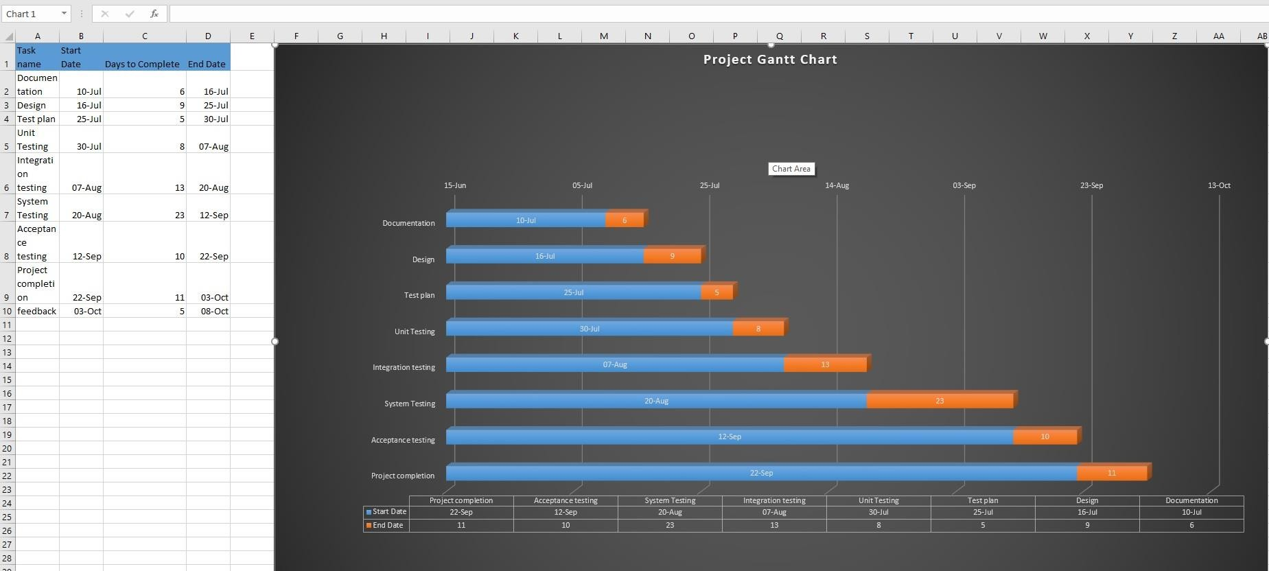

*Figure 14 : Project Testing Grant Chart.*

## PLANNING RISKS AND CONTINGENCIES

* The time interval should be followed strictly.
* The module dependency should be resolved before the delivery date.
* The client operator should be adequately trained.
* All the prototype of the software should be destroyed after delivery of the product.
* Team should scrum board to keep accountability in the task.
* “Customer is always right” should be the mentality for everyone involved in the project.
* The worst problem for any software project is the budget. The budget should be approved, and Task should be approved before the project is started

## APROVALS

|  |  |
| --- | --- |
| Project Sponsor | PASS |
| Development Management | PASS |
| EDI Project Manager | PASS |
| RS Test Manager | PASS |
| RS Development Team Manager | PASS |
| Reassigned Sales | PASS |
| Order Entry EDI Test manager | PASS |